Advocates for Harvard ROTC .

Telephone: (978) 443-9532 11 Munnings Drive

E-mail: pemusnr@hotmail.com Sudbury, MA. 01776
28 November 2024

From: Captain Paul E. Mawn USN (Ret.) To: Advocates for Harvard ROTC Subject: Crimson Warriors - Emerson Family
Harvard graduates have a long proud history of service as warriors in the US military. All gave some and some gave all!.

At Memorial Square in the center of Concord Massachusetts, the Vietnam Memorial lists the names of 5 local men Killed in Action in Vietnam (3 Marines & 1 soldier who had all enlisted) plus a Marine officer. Since I worked in Concord, I was curious about these 5 Concord warriors and viewed their background details on the virtual online Vietnam Wall Memorial. The Marine officer named (Captain William “Bing” Emerson USMC) was born 4 days before me. From the archives of the Concord Library, I later discovered that “Bing’s” funeral was held at Memorial Church (in the Harvard Yard) & that he had graduated a year after me from Harvard where he had lived in Dunster House. “Bing” was a helicopter pilot and Silver Star recipient who was heroically Killed in Action while rescuing Marines from a hot “Land Zone” in South Vietnam. On the adjacent World War II Memorial in Concord, the name William Forbes Emerson (“Bing’s” uncle) is also listed. He was a pilot in the US Army Air Corps who killed during that conflict. “Bing’s” father (David) was also a Harvard grad (HC-38) & a highly decorated fighter pilot in the Army Air Corps during World War II. David Emerson was later an investment banker and retired as a colonel in the USAF Reserve. A 3rd William Emerson (“Bing’s” cousin) was a US Army 2nd LT who was Killed in Action while serving as an ariel artillery observer when his airplane was shot down in France during World War I. “Bing’s” 4th Great Grandfather who was also named William Emerson died while serving in the Continental Army during the Revolutionary War. The above Emerson patriots educated at Harvard noted above were not career military soldiers but answered the call of their country and went into harm’s way during in a serious time of crisis.

On the nearby World War I memorial erected in 1921 in Concord center, the below succinct poem was written in 1863 for the funeral service in Boston of Colonel Robert Gould Shaw (HC-1860) by “Bing” Emerson’s 2nd Great Grandfather. Colonel Shaw had served in the 2nd MA Infantry (Regiment) prior to assuming command of 54th MA Infantry (Regiment). He was Killed in Action while leading his negro (“black”) enlisted troops in a frontal assault of the Confederate Fort Wagner in SC. The following somber poem captures the essence of sacrifice by many Harvard warriors which unfortunately later was also directly applicable to the poet’s direct descendants.

“So nigh is grandeur to our dust
So near to God is man
When duty whispers low, thou must.
The youth replies I can”
Ralph Waldo Emerson (Harvard College class of 1821)

HARVARD COLLEGE by CLASS
1761
Chaplain William Emerson MA Militia (Colonel Reed’s Concord Regiment) [Died on active duty (disease)]U
Rev. Bill was born in 1740 in Concord (MA) where he lived in “The Old Manse”. After graduating from Harvard, he returned his hometown as a minister. In October 1774, Bill served as the chaplain to the Provincial Congress when it met at Concord. After the start of the Revolution in June 1776, Bill left his wife and 7-year-old child to join the Continental Army as a chaplain. Unfortunately while on a campaign in upstate NY, he died of camp fever

His only son (William, also a Harvard College graduate) became a famous preacher in Boston. Among William’s 8 children, the most famous American was the poet and philosopher Ralph Waldo Emerson (HC-1841 & the 2nd Great Grandfather of Captain William Emerson USMC),
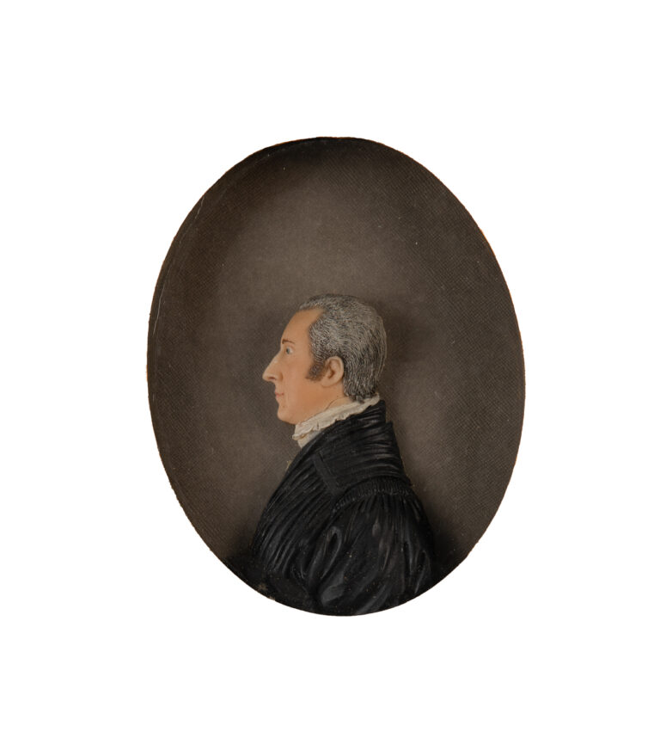

HARVARD COLLEGE by CLASS

1861
Private Stephen Goodhue Emerson - 1st Massachusetts Infantry (Regiment) [Killed in Action] Steve was born in Chester (NH) in 1838. He attended Chester Academy and then Phillips Andover prior to matriculating at Harvard College. His father was a teacher for many years who later went into business in Boston but ran into financial difficulties. As a college junior, Steve became much more religious and spent a lot of time teaching & assisting at church in Chelsea (MA). After graduating from Harvard, Steve entered the Andover Theological Seminary in September 1861 with the intent of becoming a minister. However during the following summer with the Civil War raging, Steve surprising enlisted in the 1st MA Infantry (Regiment) in July1862. After a month of basic training in Cambridge (MA), he reached his regiment in Virginia where he had 3 months of picket duty and building roads. Private Emerson was listed as “missing in action” in the battle of Chancellorsville where he fought under the command of General Hooker US Army. His family hoped that he had been captured by the Confederates but later learned that he was not on the rolls of released prisoners of war. One of Steve’s friends actually journeyed to Virginia to try and recover his body but was not permitted to reach the battlefield. Almost a year later, a recently patrolled POW & regimental mate reported that he and Steve were caught behind enemy lines during a retreat and completely surrounded by Confederates. As they were retreating, he saw Private Emerson hit by a “minié” ball which passed through his head causing him to fall and die without a word on 3 May 1863.

Private Emerson participated in the following combat engagements: Mottawoman Creek (MD), Siege of Yorktown (VA), Williamsburg (VA), Fair Oaks/ Seven Pines (VA), Oak Grove (VA), Savage Station (VA), White Oak Swamp (VA), Fredericksburg (VA), Malvern (VA), Harrison’s Landing (VA), Bristoe Station (aka Kettle Run, VA), Catlett’s Station (VA), 2nd Battle of Bull Run (VA), Fort Lyon (VA), Munson’s Hill (VA), Fredericksburg, “The Mud March” (VA), Falmouth (VA), Rappahannock Bridge(VA) and finally Chancellorsville (VA).
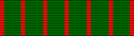

U1916
2nd LT William K. Emerson US Army (12th Aero Squadron) Croix de Guerre & Purple Heart [Killed in Action]U
Bill was born in New York City in 1894 and prepared for Harvard at the Middlesex School. At Harvard, he was on the football team and crew as well a member of the Hasty Pudding, Institute of 1770 & the Spee Club. In the summer of his junior year, he served with the American Field Service on the front lines in France driving ambulances in combat for the Allied forces.

In January 1916, he returned to Harvard and graduated with his class. He returned to France in January 1917 and reenlisted in the American Field Service where he received the Croix de Guerre for conspicuous bravery while evacuating wounded under fire near Monastir, France. At the end of the 1917, he was in Serbia and then returned to France where he was successful in getting commissioned as a 2nd LT in the US Army Field Artillery. After training and serving in the 15th Field Artillery, Bill transferred to the 12th Aero Squadron as an artillery observer. On his first flight near Toulon (France), LT Emerson was shot down and died as a result.

1937
Colonel David Emerson US Air Force Reserve (2nd fighter squadron, 52nd fighter group) Bronze Star
David (the great-grandson of Ralph Waldo Emerson [H-1821]) was born and raised in Concord MA. He graduated from the Belmont Hill School prior to entering Harvard. After college, he became a member of the Civil Air Patrol and worked for Pratt & Whitney Aircraft in CT. After Pearl Harbor, he was commissioned into the US Army Air Corps and received his wings as a fighter pilot. He flew P-51 fighters in numerous combat actions both in North Africa and across Europe from D Day until the German surrender. After the war, Dave went into investment banking and continued in the active Air Force Reserve until his military retirement in 1971. His oldest son, Bing [H-1964], was killed in action in Vietnam and awarded the Silver Star as a Marine helicopter pilot David served on numerous civic boards before his death in Concord in 1998.

1. HARVARD COLLEGE by CLASS
HARVARD COLLEGE by CLASS
1964
Captain William Emerson US Marine Corps (HMM-265, MAG-36, III MAFSilver Star&Purple Heart [Killed in Action]
William (Bing) Emerson was born in Concord (MA) in 1941. During WWI, “Bing’s” father (COL David Emerson USAFR) who was fighter pilot and his uncle (also named Bill Emerson) was Killed in Action in the Army Air Corps. “Bing’s” cousin (2nd LT Bill Emerson -HC-1916) was also Killed in Action in World War I as an aerial observer in France. In addition, “Bing’s” great-great-great great grandfather also named William Emerson (HC-1761) died on active duty from disease while serving as a chaplain in the MA Militia of during the American Revolution. By the way, Chaplin Emerson’s grandson was the poet and philosopher Ralph Waldo Emerson (HC-1821) who in turn was “Bing’s” 2nd Great Grandfather.

At Harvard, “Bing” was a resident of Dunster House and a government major. He was a member of varsity lacrosse and freshman football teams as well as the Delphic Club.

After college, “Bing” graduated from Marine Corps OCS & later The Basic School at Quantico (VA). Bing then earned his “Wings of Gold” as a Naval aviator at the Naval Flight School in Pensacola (FL). After helicopter training, he went to Vietnam in February 1968 and was Killed in Action when his CH 46 helicopter was hit by hostile fire on 20 November 1968 in Quan Nam Province in the I Corps section of northern South Vietnam. Three CH 46 helo troop carriers, (including “Bing’s”) were lost that day while transporting Marines of 3/5 into a hot LZ during the Mead River Operation in an area SE of Da Nang. The mission was to transport infantry to support Marines who were greatly outnumbered by the North Vietnam Army. The CH 46’s were exposed to heavy ground fire & hit with an RPG and small arms file while going about 50 MPH about 50 feet off the deck. As a result, “Bing” was Killed in Action but his body was recovered and repatriated for burial with full military honors at “Sleepy Hollow Cemetery” in Concord (MA).

Captain Emerson’s Silver Star citation reads as follows: “The President takes pride in presenting the Silver Star (Posthumously) to Captain William Emerson, United States Marine Corps, for conspicuous gallantry and intrepidity in action while serving as a Pilot with Marine Medium Helicopter Squadron (HMM) 265, Marine Aircraft Group (MAG) 36, in connection with operations against the enemy in the Republic of Vietnam. On the morning of 4 November 1968, Captain Emerson launched as Section Leader of a flight of 2 CH-46 transport helicopters assigned the emergency extraction of a USMC recon team that had captured an enemy soldier and was being pursued by a large North Vietnamese Army force southwest of DaNang. Arriving over the designated area, he was requested to attempt a hoist extraction of the prisoner, and as he entered the zone and commenced a hover, his aircraft came under a heavy volume of hostile automatic weapons fire, forcing him to abort the extraction attempt. After refueling and rearming at An Hoa, Capt. Emerson returned to the hazardous area and, observing a potential landing zone, guided the ground unit to the designated position while calmly providing the patrol with words of encouragement. When the Marines arrived at the site, they informed Capt. Emerson that the zone was unsuitable for landing. Realizing the seriousness of the situation, he unhesitatingly elected to attempt the extraction and, skillfully maneuvering his aircraft in an evasive approach to avoid detection by the enemy, fearlessly entered the area and hovered with the loading ramp resting on an abandoned hostile bunker. As the patrol embarked, the aircraft came under intense enemy automatic weapons fire supporting an assault by a large North Vietnamese Army force. Disregarding his own safety, Capt. Emerson steadfastly maintained his dangerously exposed position while directing armed helicopters in attacking the advancing enemy, forcing them to withdraw. When the hostile force delivered anti-tank rocket fire at his aircraft, he ignored the rounds impacting nearby and calmly waited until all the team members were on board, and then rapidly departed the hazardous area. By his courage, superior aeronautical ability & unwavering devotion to duty, Capt. Emerson inspired all who observed him and upheld the highest traditions of the Marine Corps and of the United States Naval Service.

Fair winds and following seas,

Paul E. Mawn (H-63) Captain USN (Ret.) Chairman Emeritus - Advocates for Harvard ROTC

Sources: Harvard Alumni Magazine and various Harvard reunion reports plus information from various veterans and their families. Harvard undergraduates in particular as well as others should be aware and appreciate that many Harvard alumni before them paid a price in time, blood and restricted earnings for our national security and liberty. Such military veterans at one point of their life wrote a blank check made payable to the USA for an amount up to and including their own life. “Freedom is not free”.

